Asorath
Aso-Wrath, After Death.
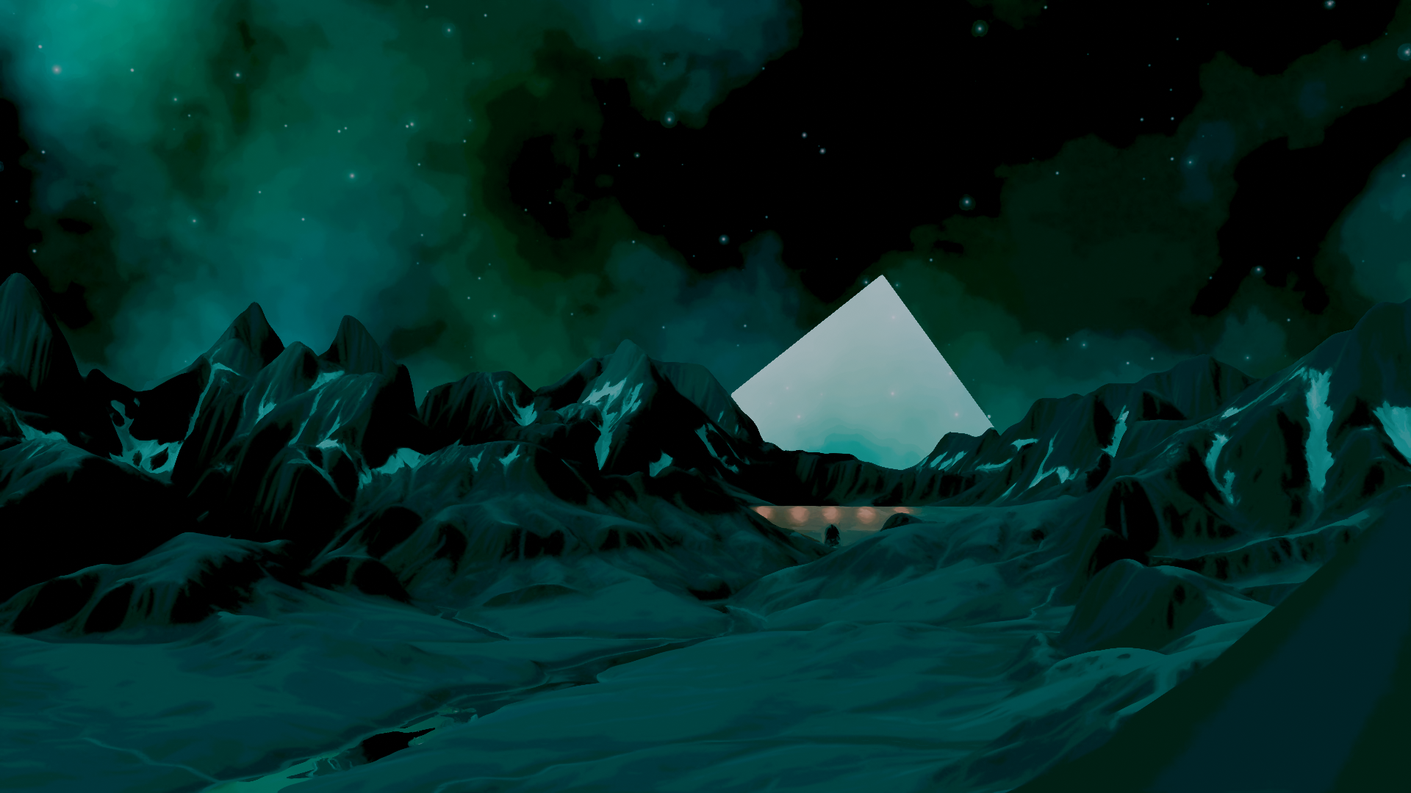
By Roxxanne Ward & Co
Table of Contents
Basic Mechanics 3
Attribute Checks 4
For Players 4
For DMs 4
Weight and Encumbrance (optional) 5
Status Effects 5
Skills and Skill Checks 6
Adrenaline and Max Adrenaline 7
Learning 7
For DMs 7
Map Travel 8
Party Speed 8
Encounters 9
Example Encounters 10
Encounter 1 – Spawn a slime 10
Creating Your First Character 11
Peoples and Races. 12
Elves 12
Full Elves 12
Orcs 12
Full Orc 12
Half-orc (Elven) 12
Krukow 12
Living Familiars 13
The Livingwood 13
Humans 13
Actions 14
Stamina 14
Inventory 14
Battles and Battlemaps 15
Battlemaps 15
Turns 15

SUMMARY
ASOYU is a work-in-progress Tabletop Roleplaying Game inspired by the likes of Dungeons and Dragons/Pathfinder and Wogwo’s Run, Stab, Kill, Kill.
This game was designed by Roxxanne Ward, Me. I have not played much DND, and I have not at all played Pathfinder, but I get the mechanics. I did not find the DND system extraordinarily fun in my little time playing it majorly because of how much unnecessary math there is to do for not a lot of actual gameplay, as such I have a handful of priorities when designing this game:
- Minimizing time doing math
This means simpler calculations, less kinds of dice unless necessary and reusable equations. (if you add any more math to DND, it just starts becoming HYBRID.)
- More in-depth systems
As far as I understand it, DND’s magic system is just fancy actions with mana. I prefer to have a system which is theoretically uncapped and integrates well into lore. Additionally, I enjoy RSKK’s status effect system in which most status effects have a nominally neutral effect, such as the Cancer status effect where you roll 1D6 for every turn and either destroy the organ if you roll a one, or gain one pre-cancered skin organ if you roll a six.
- Open campaign design
In my opinion, one of the coolest parts about DND/Pathfinder is that you can just write your own campaigns, create your own mechanics for those campaigns, Homebrew.
- Class freedom
As of yet in development, I have not yet figured out the class system, however it would be preferable if classes primarily grant initial bonuses instead of primarily granting through-campaign bonuses so that as the tone of the campaign and needs of the player change, they are not locked in to two super-attributes they are proficient in, but that they can branch out from their initial specialization if it seems necessary.
Being a first-time TTRPG designer, I admit this is very ambitious, but thats why this is a prototype!
Lore-wise, while I haven’t entirely figured out the lore of ASOYU, I have an idea of it. (ill get back to this later in a lore-focused section)
And also, at the end of this document, there may be a Google Forms link asking for opinions on specific mechanics, particularly those listed with two separate mechanisms.

ASOYU
Welcome to ASOYU/Asorath/Asowrath/Aso! This is an in-depth WIP TTRPG loosely based on DND to an extent which does a lot of unique things in the pursuit of making a TTRPG which doesn’t make the sacrifice of being mechanically shallow while prioritizing time actually doing fun things like throwing dice or strategizing instead of doing math.
In this game, every player excluding the so-called Dungeon Master creates a Character, of which through they are granted the ability to interact with the world of Asorath. Character creation will be on a page following this one.

Basic Mechanics

ASOYU is a very varying game by its own nature of being largely story & player driven, but most campaigns follow a basic gameplay loop:

- The Dungeon Master describes the environment in detail.
A chest on the far wall, a door with a keyhole on the nearest, perhaps a goblin guarding the aforementioned chest and maybe even esoteric symbols covering the walls. Maybe you’re in a bustling city, maybe you’re in a small town well past its golden age. Maybe you’re in a bog or a dense forest. Whatever it is, there’s always something to do!
The DM will in some cases provide a map of the location, but otherwise will describe how many doors lead out of a room or who is in that room, giving the players an ample amount of detail so that they may figure out what they want to do.
- The players then describe what they would like to do.
See a goblin? Lets fight it!
Maybe a stealth-oriented character who has invested into their lockpicking skill will see a particularly interesting-looking locked door and the DM will tell them to skill-roll lockpicking, they end up succeeding the roll with a nat 20, and unfortunately there were not many riches behind the door, but in fact a hooded creature with no face, Uttril the Voracious, an evil spirit given necronic form.
- The DM then describes the results of the players’ actions.
The players successfully fend off the evil soul and banish it to Voulvundan. As a result, several members of the party gain XP, and they find gold on the torn cloth the apparition had donned, only taking minor injuries which will heal passively. Overall, a victory!

Attribute Checks

For Players
In battles, conversations and any other interaction, you will often be asked to complete an Attribute Check/Roll, this is a simple dice roll to check how proficient you are in certain abilities, such as strength.
Asoyu has three kinds of Attribute Check, using Strength as an example:
- Regular (1D20 + Attribute + AdrD4chart)
Roll 1D20, adding your Strength number, then rolling 1D4 for every level of Adrenaline you currently have, and adding according to this chart:
  - 1 – -1
  - 2 – +1
  - 3 – +2
  - 4 – +3
- Combined (2D10 + Superattribute)
Alternatively, you can roll 2D10 and add both attributes under Prowess, Strength and Endurance, but lose the Adrenaline bonus. You may use a Combined roll any time unless the DM says it is not available for whatever lore reason.
- Additive (xD10 + (Attributes = x) ) (Event Only)
Sometimes, a DM, mechanic or campaign script element may require an “additive” roll, rolling for more than one attribute at a time. These are rarer and players cannot willingly choose or deny them, but it is important to know how they work.
  - When given an Additive roll, you roll 1D10 for every attribute in question, and then add the collective dice roll to the attribute levels.
This system (particularly the Regular/Combined split) is to allow for more player agency and strategy within simple attribute checks. A way to see it is the Regular check style is using only one skill to solve a problem, like brute forcing, while a Combined check is using innovation to devise a solution which may or may not work better.
Also, some skills may add bonuses to rolls, more on that in the Skills section.

For DMs
While Additive rolls are an intentional mechanic, they should be used sparingly and be less common until you get to the mid-late game. Additionally, they operate on a different scale from Regular rolls.
The Regular/Combined and Additive scales will be shown on the next page
Regular/Combined
- 5-10 – Easy
- 10-20 – Intermediate
- 20-30 – Hard
- 30-40 – Very Hard
- 40-50 – Hadic
- 50+ - Godlike
Note for DMs, Optimally, Attribute Checks shouldn’t exceed 55 except in extraordinarily rare scenarios, as this is the maximum possible roll with a Regular roll excluding circumstances with roll-bonus skills due to the maximum level of Max Adrenaline being 5 and the only way to exceed the Max Adrenaline cap being by electrocution.

Additive (2 Attribute)
- Easy – 5-20
- Medium – 20-40
- Hard – 40-60
Note For DMs, For every Attribute added beyond two, the top-end increases by thirty, and the minimum increases by one. So for example, a 6 Attribute roll has a minimum of 6 and maximum of 180.

Weight and Encumbrance (optional)
Carried weight plays a large part in long-distance travel.
To start, all items have a weight in kilograms and size in size classes. Players have a “weight encumbrance” stat in the form of a percentage with a maximum determined by their strength stat.
TBD

Status Effects
Status Effects are an extremely large part of Asoyu and as such will have a full section later, but for a quick rundown or a refresher for returning players:
Status Effects are any effect which do an action per every turn, this can be the fact that you are on fire, dealing burn damage for every turn, or can be the fact that you are under the influence of a fire resistance potion/spell, negating a percentage of or all fire damage. As stated before, Status Effects are a very large part of Asoyu and will have a full section later.

Skills and Skill Checks
Skills in ASOYU are somewhat different from their implementation in DND/Pathfinder, in most cases unlike being a straight addition to a roll, they act as specific abilities, things you can do.
Every Superattribute has 3 skills which all either give you the ability to do something, or give bonuses to other rolls (like adrenaline rolls). All skills are either binary or have levels, and are “paid” for using their respective Superattribute’s total as a capacity. All skills start at zero and can be reallocated by one per level up. Binary skills use two points.
This section is TBD, I’m moving on to Adrenaline for now.
Below is a list of skills.

Prowess (Strength and Endurance)
- Heavy Armor – Grants the ability to wear Heavy Armor – Binary
- Heavy Weapons – Grants the ability to use Heavy Weapons – Binary
- Instinct – Roll a dice any time you do an action using Adrenaline, according to the following chart, add to every adrenaline roll. – Leveled (max 3, use D3 for 1, D4 for 2 and D6 for 3)
  - 2-3 | +1
  - 4-5 | +2
  - 6 | +3
Agility (Stealth and Dexterity)
- Acrobatics –
- Lockpicking –
- Grip –
Intellect (Innovation and Wisdom)
- a
- b
- c
Social (Persuasion and Deception
- a
- b
- c

Adrenaline and Max Adrenaline
Adrenaline is a mechanic unique to ASOYU, primarily acting as a force multiplier for regular rolls. As of now, this is it’s only usage, so this section will be short.
Your Max Adrenaline can be increased by 1 for two attribute upgrade points once per level-up, up to a limit of 5.
In combat, Adrenaline depletes by 1 for every turn you go without directly dealing damage to an enemy. Every time you directly deal damage to an enemy, it replenishes by 2, and whenever you are damaged, it replenishes by one. When entering combat, your Adrenaline is automatically put to max unless you are the aggressor.
Outside of combat, Adrenaline does not passively deplete, but is used up by 1 every time you do an action using it.
Other notes.
Shock damage does not just replenish your Adrenaline, but flatly increases it by 2 any time you take damage, allowing for you to temporarily exceed Max Adrenaline.

Learning
Learning is a simple mechanic. Every time you level up, you get Attribute Points which can be spent to level up Attributes, Max Adrenaline.
Whenever you level up, you roll as many D20s as you have levels in Learning, and for every D20 that lands over 12, you get one extra attribute point. All characters start with one Learning.
Learning is a very powerful mechanic, and as such, extra levels in Learning can only be granted by the DM unless the DM chooses to allow a level-up mechanic.

For DMs
If you so choose to allow a level-up mechanic, the level-up cost in learning should never be lower than that of Adrenaline.

Map Travel
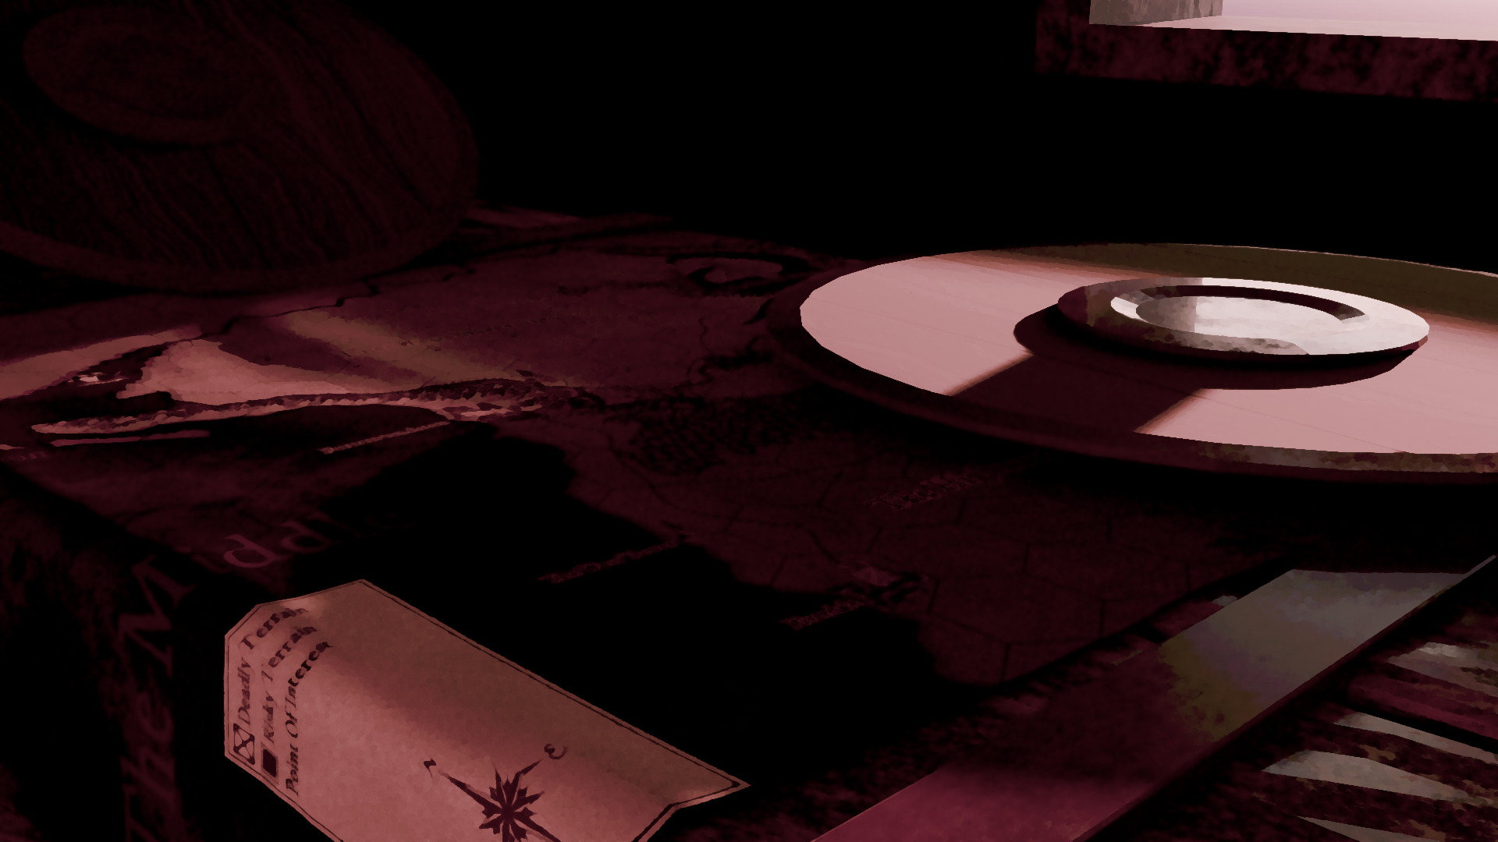
Map Travel is a large part of multi-session campaigns. Campaign Maps for ASOYU campaigns always have a hexagonal grid, this should be scaled to be approximately one day’s travel (for a single experienced hiker) in flat terrain, or two day’s travel in rougher terrain, or about 50 kilometers from one point to the opposing point.

Party Speed
Every character has a speed determined by the average of their Endurance stat and the Stride of the character’s people, an arbitrary number which serves to ensure gnome-sized characters don’t walk as fast as a giant, ranging from 6 to 20.
This is your speed in km/h in flat terrain. A human or elf typically has a Stride of 10, giving them a maximum unbuffed speed of 15 km/h and minimum unimpaired speed of 5 km/h.
Characters can carry other characters 3 feet shorter than themselves, removing the carried character but incurring a 0.9x speed debuff on the carrier’s speed unless the carrier is more than 6 feet taller than the carried. This mechanic was added for the explicit reason of making travel with an extremely short party member less painful.
(cont.)
The Party Speed is the average of speed of all party members, multiplied by 0.8 for flat terrain, 0.6 for rough/hilly terrain or 0.5 for mountainous/cavernous terrain, rounded up.
For every 4 hours you spend walking (about twice a day for average characters), the DM may choose to (optionally) roll up to 3D6 for an encounter of their choice depending on if the tile you are walking through is considered Safe (1D6, 5+), Risky (2D6, 7+) or Deadly (3D6, 9+).
Overall, a party with an average speed of 10 km/h of similarly-leveled humans can cross a flat map tile in about 6.25 hours, adding on encounters and events, a full flat map tile should take about an in-game day to cross. If traveling a marked path, increase your terrain multiplier by +0.1.
If the edge of a tile seems to have cliffs or is specially marked, you cannot cross that tile edge. (Better system for determination coming soon).
Much of this math can be combined into one equation: (10+10+1+6+20+20+12+8)/8 * 0.8, swap the even numbers for each player’s endurance and odd numbers for each player’s stride, and the 0.8 for the actual multiple of the current terrain, along with the /8 with double of your player count. This equation does not account for the Carrying mechanic, but can be made to via removing the carried character’s stats and multiplying both of the carrier character’s stats by 0.9x unless they are over 6ft taller than the character they are carrying.
When a point of interest exists within a tile, passing through that tile will always cause the players to enter it unless they explicitly choose to avoid it.

For quick identification in case of an unmarked map:
Deadly terrain is typically mountainous or canyonous.
Rough terrain is typically hilly or forested, or is desert.
Safe terrain is typically fields or plains.
(this entire system sucks, feel free to just average 10-10 for everyone regardless of level until I can get a better system)

Encounters
Encounters are either random or scripted campaign-specific events which can occur during travel, often chosen either by a scripted event or DM’s dice roll, and in the case of the latter, are picked by the DM.
These can vary from simple item pickups to initiation of battles with packs of wildlife to minor story events and buffs.
What they have in common is that they are often unexpected to the party, and if aforementioned party is in poor condition, encounters can change their fate for better or for worse.
Possible encounters can vary from region to region, for example, you might only encounter a battle with a pack of wolves in forests, you may only encounter a certain witch in a specific swamp, or you may only find nuggets of a certain material on one continent.
Some example encounters will be presented at the end of this chapter, but all future official campaigns will have a thorough encounter list, and all player-made campaigns (homebrew) should have a decent, varied list of potential encounters.

Example Encounters

Encounter 1 – Spawn a slime
Traveling through forest or plains, pretty easy encounter.
“While traveling on your path, (a random party member) steps into a puddle of chapel-blue goo. The goo swiftly accumulates from the surroundings and manifests itself in the form of a solidified wall which blocks the path. You may choose to try and destroy it, or to turn back and find a different path.”
Players choose to destroy it – any party member rolls for Strength, DC 20. If successful, players may continue on their path, if unsuccessful, start battle with a Hardened Slime of a level at the DM’s discretion.
Players choose to turn back – the direction the players were traveling through that tile is blocked for 24 in-game hours.

Creating Your First Character
Character Creation is a major part of Asoyu, obviously, and to start, there are several things you must choose, being your people and race, and several things which you do not get a choice in (unless running a full-creation system), such as your upbringing (backstory) or are dictated by other systems such as your ideology.

Peoples and Races.
Asorath is a very diverse world, and as such, there are many Peoples, traditionally called Races, to pick from. While no people is inherently better than another in this World after Death, some were favored by Heieris in their creation or are materially shaped by

Elves
The first creation of Heieris, according to Elven myth. They call themselves Eladorin and primarily speak Elvish, with lowermen often speaking Trade and uppermen often speaking Noble. All party characters speak Common, the diplomatic language based on Wessuric Elvish.
Stride | Size |  |  | Languages
12 | Medium |  |  | Teidaric Elvish or Wessuric Elvish depending on Culture | Trade if following a Lower Class backstory or Noble Elvish if following an Upper Class backstory.

Teidar Elves
The primary culture of Elves north of The Middle, typically bearing all-white hair and green-on-white eyes. Teidar Elve cities are rich but often encircled by a large ring of slums, inhabited primarily by the lower class, immigrants and non-elves.

Wessuric Elves

Backstory
Everyone brought up in this world has a story to tell, be it one of fear and ruin or one of luxury and greed. Your backstory typically determines which ideology you can choose from.
First roll 1D4

Lower Class
The lower class, steeped in slums and bathed in the blood of their fellows at the hand of their overlord, yet most often are the backbone of society.

Industrial Worker
Growing up in a more advanced society, you became a worker in an industrial factory or similar at the first age of maturity. While this means you are physically more durable, your education was unfortunately cut short.
+2 Proficiencies | +1 Proficiencies | -1 Deficiencies | Traits | Available Ideological Spectrum(s)
Strength | Dexterity | Innovation | Tough - | Leftist  Anarchist

Actions
An action is anything a player or enemy can do beyond Roleplaying, including attacks, battle movements and spells.

Stamina
Your stamina is a capacity for how many actions you can take during your turn, roughly, moving one tile will take 1 stamina, swinging a shortsword will take 2, pulling a bow or swinging a longsword will take 3, and magic heavily depends on the spell, its power and resource requirements.

Inventory
Your inventory contains items, it can contain keys, regional currencies (non-gold), tools, spare armor, weapons, food and anything in between. Your inventory consists of a list of items, as well as a secondary 3x3 graph showing your currently equipped weapons, seals (magical wearables) and armor.
Seal 1 | Helmet | Seal 2
Right Arm | Chestpiece | Left Arm
Primary Weapon | Leggings | Secondary Weapon
Armor can cover more than one of these slots, many chestpieces will also cover the arms if specified. Additionally, if a weapon specifies it is two-handed and if you do not have an item which makes two-handed items one-handed, it takes up both the primary and secondary slots.

Item Actions
Most items which you would attack with should have a section under their description listed “ACTION” or sometimes “ACTIONS”, formatted something like this for a simple longsword:
Name: | Mechanic: | Properties: |  | Consumes:
Swing | Roll 1D8 + Str + Adr or 1D8 + PRO, deal equivalent Sharp damage to the enemy and Bleeding status effect if applicable. Subtract 2 from damage if one-handed. | Versatile.  Can be used one handed or two handed. | Sharp.  Deals Sharp damage and causes Bleed | 2 Stamina
Charge | Roll 1D12 + End + Adr or 1D12 + PRO, deal equivalent Sharp damage +2 Blunt to the enemy and Bleeding status effect if applicable. Two-handed only.  May be used from up to 3 tiles away, moving the player to the enemy’s former tile and pushing the enemy back one tile. | Sharp.  Deals Sharp damage and causes Bleed |  | 4 Stamina

Battles and Battlemaps
Battles are an integral part of ASOYU. From a one-on-one scuffle with a patron in an underground bar in the Urbana to a battle with a dark lord which will determine the fate of Asorath.

Battlemaps
All battles take place on battlemaps. Every battlemap has tiles, each about 4 ft by 4 ft and can have objects or living things in them. Tiles should be square.
Battlemaps do not necessarily have to be used for battles, in general it is a good idea for DMs designing a campaign to have a battle map for POIs (like an abandoned tower) and buildings within larger POIs (a tavern, a barracks, other things of the sort), but if a battle isn’t intended to happen at a location like that, then it’s mostly for flavor.
Players and enemies will start on the battlemap in locations determined either by roleplayed-out mechanisms (if you’re at the bar of a tavern and someone starts picking a fight with your party, your party will start at the bar) or, if the players were not moving their tokens around on the battlemap or a pre-existing battlemap does not exist, then the DM may determine where the players and enemies start.

Turns
Roll 1D20 for every combatant, order progresses from highest roller to lowest.

- a Superattribute, discussed in Character Creation, but for quick definition, there are 8 attributes and 4 Superattributes of which two Attributes fall under per.

